**Government College Of Engineering, Amravati**

(An Autonomous Institute of Government of Maharashtra)

Department of Information Technology

(2018-2019)

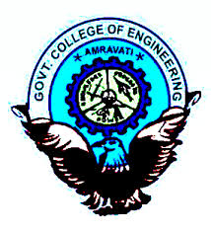

PROJECT REPORT

ON

**“TECHNOMATE”**

Submitted By:

Divya D. Dubey(17107001)

Komal P.Manoja(17107007)

Adarsh H. Basantwani(17107008)

Guided by:

Prof. A. D. Wankhade

Teacher Staff

(Department of Information Technology)